Inventory Enterprise DFCI FRS - Commercial

Date Printed: 8-Nov-26

Publication Record
Version | Date Revised | Primary Author | Description
1 | 1/10/2008 | Patrick Donovan | Initial version

Publication Record 2
Definitions 4
Drug date management 4
Overview 4
Requirements Addressed 4
Proposed Solution 4
Implementation 6
Testing 6
Par Levels 7
Overview 7
Requirements addressed: 7
Proposed solution 7
Implementation 7
Ordering 8
Overview 8
Requirements addressed 8
Proposed Solution 8
Implementation 9
Receiving 12
Overview 12
Requirements Addressed 12
Proposed Solution 12
Implementation 12
Replenishment 13
Overview 13
Requirements Addressed 13
Proposed Solution 13
Implementation 13
Bulk transfers 14
Overview 14
Requirements Addressed 14
Proposed Solution 14
Implementation 14
Decrementing 15
Overview 15
Requirements Addressed 15
Proposed Solution 15
Implementation 15
Appendix A: Decrementing TDS 16

Definitions

Buy Units – the package size of items bought from the Amerisource Catalog (for example, 10X10ml will have 10 10ml bottles per package)
Sell Units – the intermediate unit that can be used to transfer drugs (for example, in a 10X10ml package, the sell unit would be 10 bottles)
Dispense Units – unit stored in inventory, and decremented with dispensed. For example, for a 10X10ml package, the dispense units would be 100ml.

Drug date management

Overview
DFCI requires certain information to be stored in Inventory. While the drug database will reside in a different system, certain fields will be important for the inventory operation. NDC code, BDPP, and drug type are required for all drugs in the compound database in inventory. For commercial drugs, a field to mark “Critical Drugs” for bump up during restocking should also be included. In addition, the protocol id, optional NDC code, and a Boolean placebo field should also be stored.. DFCI also requires space for GCN and PCN numbers for future use. Finally, the package size for container unit lookup purposes should also be included.

Requirements Addressed

Proposed Solution
The following fields have been added or configured:

Field | Level | Inv. Field | Commercial | Blood/Vaccine | Investigational
NDC | Drug | CAS | Required | Required | Optional
BDPP | Drug | ALT_ID_ | Required | Required | Required (unique for each drug in protocol)
GCN | Drug | ALT_ID_2 | Future Use | Future Use | Future Use
PCN | Drug | ALT_ID_4 | Future Use | Future Use | Future Use
Drug Type (Commercial, IDS, Vaccine, Blood | Drug | ALT_ID_5 | Required | Required | Required
Protocal Id | Drug | ALT_ID_3 | N/A | N/A | Required
Is Placebo? | Drug | Custom Boolean | N/A | N/A | Optional (Y if checked)
Is Critical Drug? | Drug | Custom Boolean | Optional (Y if checked) | Optional (Y if checked) | N/A
Package Size | Drug | Package_Size (new) | Required | Required | N/A
ABC # | Drug | ACX_ID | Required | Required | N/A
NDC for Investigational | Drug | NDC_INVESTIGATIONAL (new) | N/A | N/A | Optional
Lot Num | Container | Lot_Num | N/A | Required | Required
Expiration Date | Container | Date_Expires | N/A | Required | Required
Container Id | Container | Barcode | Required (unique but not significant) | Required (unique but not significant) | Required (unique, possibly significant for drugs tracked at the container level)
Transaction ID | Container | FIELD_10 | Last decrementing seqnum | Last decrementing seqnum | Last decrementing seqnum
Dose | Container | FIELD_4 | n/a | n/a | Dose for dispense
MRN | Container | FIELD_5 | n/a | n/a | MRN for dispense
Patients Initials | Container | FIELD_6 | N/a | N/A | Required for dispense
Dispensing Pharmacist | Container | FIELD_3 | N/A | N/A | Required for dispense
Kit # | Container | Barcode | N/A | N/A | Optional. Part of barcode identifier

Implementation
Configured fields are automatically added to the drug and container management pages. Any new fields must be added through custom code and are not searchable. All fields are accessible for reports. All container fields are accessible for update with the decrementing interface. The additional fields for drug management are shown in figure Figure 1 Drug Management Screen. Note that NDC is required for commercial drugs, and protocol id is required for investigational drugs, depending on the drug type selected.

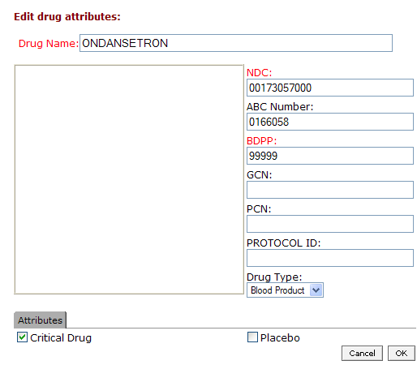
Figure 1 Drug Management Screen

Testing
1) Check to see all fields are accessible and can be edited.
2) Check to see that NDC is required for commercial drugs, vaccines and blood products, and that protocol id is required for investigation drugs based on Drug Type.
3) Some fields for containers do not need to be shown. For example, Transaction_Id is the last decrementing transaction that updated this item. It can be accessed via the audit table reports.

Par Levels

Overview
DFCI requires that par levels for drugs be stored for specified locations. These levels are used for reorder and replenishment points for both the central pharmacy as well as satellite pharmacies. Par levels will need to be listed for all items in storage for a particular area (even if the par level is 0), as well as for any item with a par level greater than 0. Items not stored at the location with a par level of 0 need not be listed in the results.

Requirements addressed:
- Par Level Amount defined for drug (compound) and location combination
- Method of maintaining par levels for central and satellite pharmacies.
- Par level to be used for reorder and replenishment based on location type.

Proposed solution
CS proposes a search and editing grid, allowing the end user the ability to search for par levels by location and by NDC code (cas). The user can make changes and update the par levels. These par levels will be adjusted when the changes have been submitted, and will be used in all future replenishment and reordering functions. Areas designated as “Pharmacies” (location_type_id_fk of 1002) can be replenished from Central Pharmacies, Central Refrigerator or Carousel. Central and Main Pharmacies use the par level to reorder drugs from Amerisource.

Implementation
One interface manages the par levels for the application. The interface is accessed on the launch page with the “Par Level Management” link.

- Searching
- Editing – Update the par level and click “OK”
- Adding – Fill in the first row with NDC, location id and par level in dispense units and click “OK”.

To remove a par level, simply zero it out.
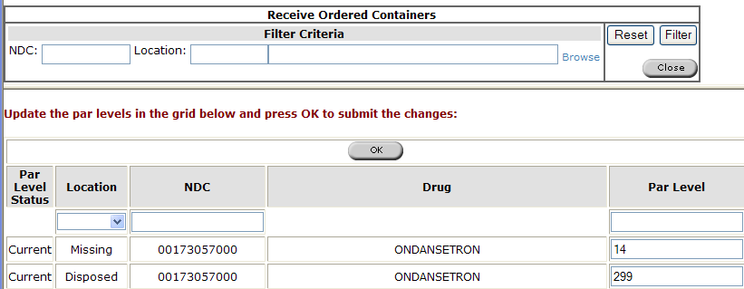
Figure 2 Par Level Management

Ordering

Overview
Two mechanisms exist for ordering. The bulk of items are reordered through a reorder interface that checks on the amount on hand as well as the defined par level, and determines the amount of drug that should be ordered. DFCI also requires searching and ordering for drugs a la carte.

Requirements addressed
- Par level reordering
  - Reorder based on par levels defined for the main pharmacy
  - Allow bump up of “Critical Drugs”, with the appropriate checkbox selected in Manage Substances.
  - Adjustment of the reorder amount prior to submitting the order
- A la carte reordering
  - drugs can be searched by name, ndc or synonym and reordered from a catalog
  - The amount can be adjusted prior to sending to inventory
- All Orders
  - Containers in an order of a like NDC are consolidated. That is, 10 bottles of 100ml is consolidated in inventory as a single container of 1000 with the per unit cost as the cost. The order size is adjusted in buy units.
  - A PO must be assigned to each container for reporting and receiving purposes

Proposed Solution
For a la carte orders, CS will use the Chemacx database. This will include a mechanism to add drug database information, and upload the ChemACX data. The drugs will be searchable based on synonym, brand name, NDC and catalog number.

For bulk reordering, CS will implement a new interface that will generate a list of required items for a specific main pharmacy based on the Par Levels defined by that drug, as well as the items currently in inventory. Once a PO number has been assigned, and the reorder amounts have been approved, the items will be added to the On Order location awaiting receiving.

For both a la carte and bulk reorders, the amount ordered will be changed based on the sell units of the item. A PO number and average cost per dispense unit will be associated to each ordered drug. In addition, the ordered items are consolidated into a single container in inventory of the dispense units.

Implementation
For a la carte items, the ChemACX database has been restructured to support the Amerisource catalog and DFCI drug database. Therefore, all drugs are searchable by ndc code, brand or generic name, or catalog number. These items can be ordered and sent to Inventory associated to a user-defined PO number. The workflow is the same as the normal ChemACX ordering, with some minor additions of certain fields to support specific DFCI requirements. Some changes have been made on the search screen so that structure is not included. See Figure 3 - Figure 7 for the ordering workflow. Once the last screen is committed, the ordered items will appear in the inventory “On Order” location.

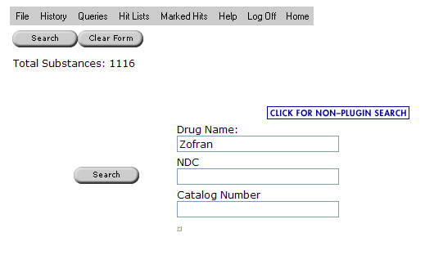
Figure 3 ChemACX Drug Search

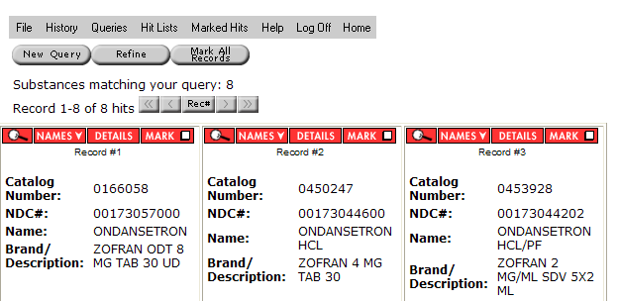
Figure 4 ChemACX Item selection

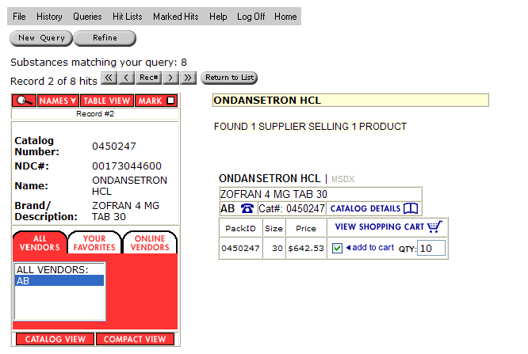
Figure 5 ChemACX Item Quantity Selection
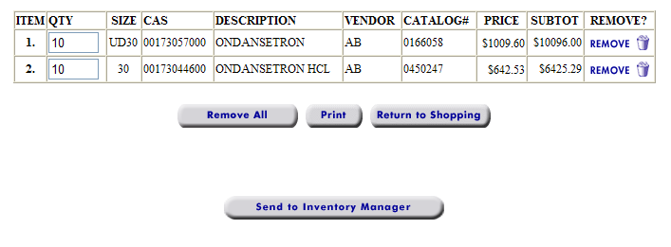

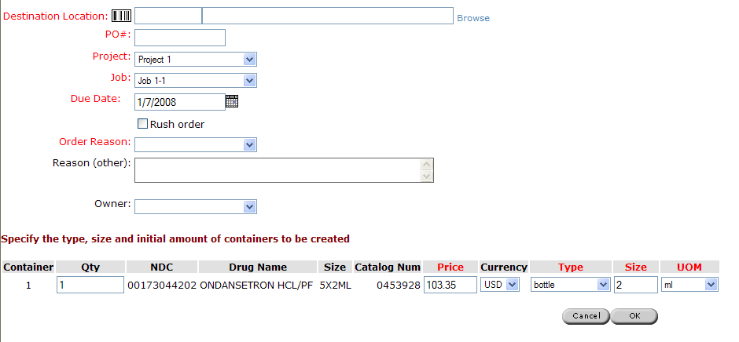
Figure 6 ChemACX Order Information

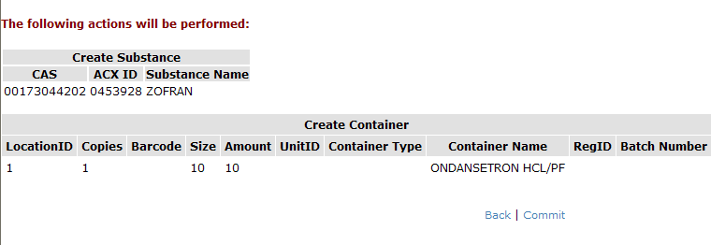
Figure 7 ChemACX Summary and Commit Screen

For automated reordering based on par level, use the “Reorder” link on the launch page. Select a pharmacy for reordering, either main or central pharmacies are listed. Relevent sublocations (carousel, refrigerators) will be listed. Fill in a bump up percentage to increase the required level for this order.
The required items will appear in the lower pane. The amounts (in buy units) can be adjusted as needed. The delivery location defaults to the location for which the par level is defined. A purchase order # must also be added. The checkbox at the top of the form must be checked off to initiate the order. Once the order is accepted, the items will be created in the “On Order” folder awaiting receiving.

Receiving

Overview
This interface allows users to receive ordered items based on searchable criteria and barcode synonyms.

Requirements Addressed
DFCI requires a receiving interface to quickly locate, update and put away items into inventory. Specifically, DFCI requires a put away field, a comments field, and the ability to update the amount received (in sell units) and the price. In addition, DFCI uses barcode synonyms for tracking commercial goods. These barcodes are unique to a specific drug. DFCI requires that on order items be searchable based on that barcode. If no barcode is found, DFCI requires that the barcode be added for that specific drug. This event must be reported so that the barcode can be added to the drug dictionary used by the pharmacy system. Finally, DFCI requires that the drugs be put away to a preferred location.

Proposed Solution
CS will provide a screen allowing On Order items to be searched by PO number, barcode, and other criteria. If a searched barcode is found in the on order location, that barcode is automatically populated in the appropriate field. If it is not found, the user must find the item of the proper NDC and full in the barcode there.

Once a barcode has been populated, the end user can select a status of the item, which will determine if it is put away or put on order. The preferred location is the destination, since carousel and freezer par levels will specify the location for the drug specifically.

Changes are added to a table where they can be included in reports. Items that are “Put Away” are sent to the delivery location, while any other designation will cause the items to remain in the on order location until rectified.

Implementation
The functionality is available in the Receiving screen on the launch page of the application.

- Search for items in a PO
- Add barcodes for items
- Search for a pre existing barcode. Barcode scans are cumulative, so a list of them can be populated. If the barcode item exists, then the “put away” field is automatically selected so the user does not need to adjust it.
- Receive items in buy units into the delivery location.

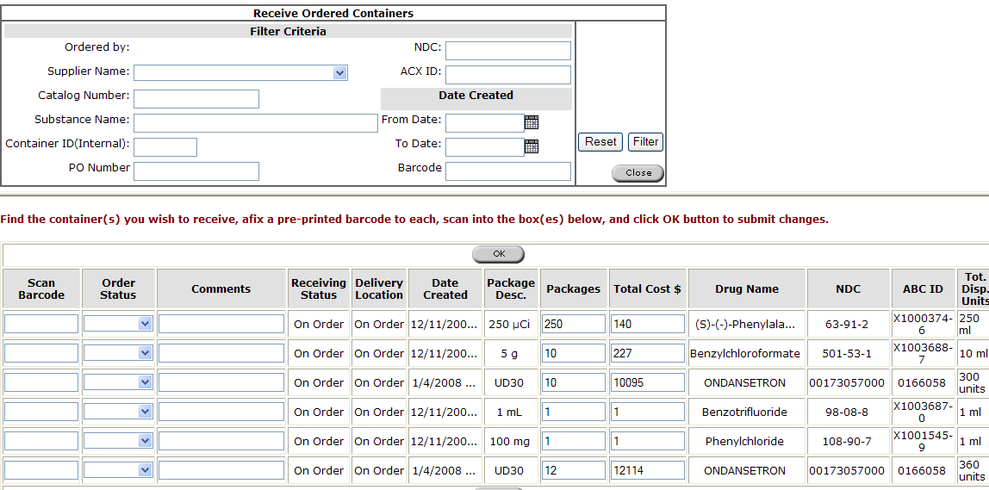
Figure 8 Receiving Orders

Replenishment

Overview
Replenishments are run daily by DFCI to ensure that satellite pharmacies have adequate drug supplies. The replenishment amount is essentially the difference between the amount on hand at a particular location and the par level amount.

Requirements Addressed
- Generate par level requests based on the amount on hand and the par level for the location
- Allow a bump up percentage to be added to drugs marked as “Critical”
- Use central pharmacy, freezer and carousel locations as the source locations

Proposed Solution
CS will provide an interface to generate replenishment requests for a specified location. The end user can change the amount to be delivered in sell units, and then mark the item to be delivered. The checked items will be transferred to the new specified locations.

Implementation
The “Replenishment” link on the launch page launches this interface.
- Pick a location
- The resulting lists are the items that must be replenished in sell units.
- The amounts can be updated as sell units. The resulting transfer will be in the corresponding dispense units.
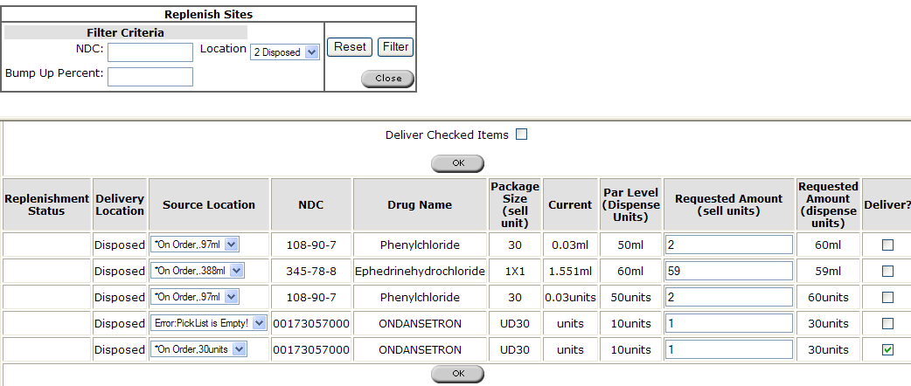
Figure 9 Replenish Pharmacies

Bulk transfers

Overview
DFCI requires a mechanism to bulk move drug supplies from location to location for commercial drugs.

Requirements Addressed
- Searching for drug supplies in a particular location by NDC.
- Transferring supplies to a new location in bulk using Sell Units.

Proposed Solution
CS will provide an interface to allow DFCI to search for drugs of a particular NDC code, and transfer a specified amount to a new location. The interface will decrement from the supplies at the source location, and create a new container with the proper dispense amount in the new location. The interface can be accessed using the “Bulk Move” link on the launch page.

Implementation
The bulk transfer interface allows locations and NDC codes to be searched. The results list allows the end user to select a source location, target location and amount to be transferred. To initiate a transfer, simply select a source location, amount, destination location and check the “Deliver” box. The source supply will be decremented and a new container with the proper amount will be created in the destination.

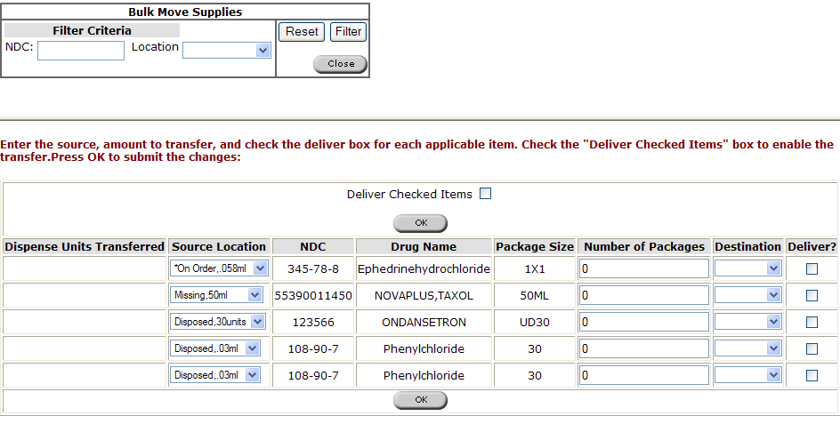
Figure 10 Bulk Moves

Decrementing

Overview
DFCI requires a mechanism for the pharmacy system to decrement the drug supplies.

Requirements Addressed
- Mechanism to decrement drug supplies
- Mechanism to credit drug supplies
- Data required for commercial drugs includes NDC, Location, and quantitiy.
- Data required for vaccines and blood supplies also include Lot number
- All decrements are associated to a pharmacy seq number.

Proposed Solution
CS will provide a stored procedure that will allow DFCI to integrate pharmacy systems with the Inventory System. The transaction will be logged in a transaction record table to ensure no duplicate transactions are initiated. Commercial drugs are not required to supply lot number, however, blood and vaccines are tied to a lot number. This interface will also allow the pharmacy to credit amounts of drugs as necessary.

Implementation
A new stored procedure, DFCI_INVENTORYUPDATE. See Appendix A for technical information on using the stored procedure.

Appendix A: Decrementing TDS
- Commercial Drug Management
  - Decrement/Update interface
    - Description:
This stored procedure is designed to be called by an external queuing application. DFCI will pass parameters to the stored procedure, which will then be interpreted by the stored procedure. Depending on the input, the stored procedure will either create the

    - Syntax
Execute the following sql command in sqlplus:

Exec dfci_inventoryupdate(<pSequenceNum>,pLocationBarcode,pNDC,pLotNum,pQTY, pTransType);

    - Objects
      - Stored Procedure: Dfci_inventoryupdate
Description
This stored procedure is called by external applications to update or decrement drug quantities at a location.

Input
pSequenceNum | Number | Unique external identifier of the transaction
pLocationBarcode | Varchar2 | Location barcode of the location we are adjusting
NDC | Varchar2 | NDC code (same as CAS) for the compound that we are decrementing. This is unique – one compound, one ndc code.
pLotNum | Varchar2 | Lot num. Null for drugs with inv_compounds.alt_id_5=’COM’. Required to match decremented containers for inv_compounds.alt_id_5 of ‘VAC’ or ‘BLD’
pTransType | Varchar2 | Values: decrement or update.  decrement subtracts pQTY from the amount at that location.  update sets the amount available to be the pQTY passed to the function.
pQTY | inv_containers.qty_remaining%type | Amount to decrement, or the total quantity available at the location, depending on pTransType

Design and Behavior
This stored procedure will only handle substances with inv_compounds.alt_id_5 of Commercial (1000), Blood (1003), and Vaccine (1004). Blood and vaccines also require passing a lot number, and no lot number should be passed for ‘COM’ substances.

Decrement
When decrement is specified, the procedure decrements oldest containers first, and updates field_10 to be the most recent pSequenceNum. This field is then reset to null, however, the complete transaction (container decremented, old qty, new qty, sequence number) is available in the audit tables. If the decrement must span two containers, the first container is depleted, retired, and then the remainder is taken out of the next containers.

Update
When update is specified:
- If qty is less than available amount, then it behaves the same way as the decrementing function, where qty is removed from the oldest containers first.
- If qty is greater than available amount, a new container is created that will contain the difference.

      - Table TRANSACTION_RECORD
Description:
Contains the transactions passed to inventory, an status of the transaction. It will only allow one transaction of a particular sequence number to complete. If that sequence has already been passed to the stored procedure, and completed successfully, it will produce an error code.

Table of Status Codes
Status Code | Description
-8000 | Not a COM, BLD or VAC compound.
-9000 | No Compound matches
-9001 | Multple compound matches
-9002 | Multiple location matches
-9003 | No Location matches
-9004 | No lot num for BLD or VAC
-9005 | Not enough supply at location to fulfill request
-9007 | pQTY is negative
-9100 | Transaction already has completed successfully.

